Nine Heads Roulette
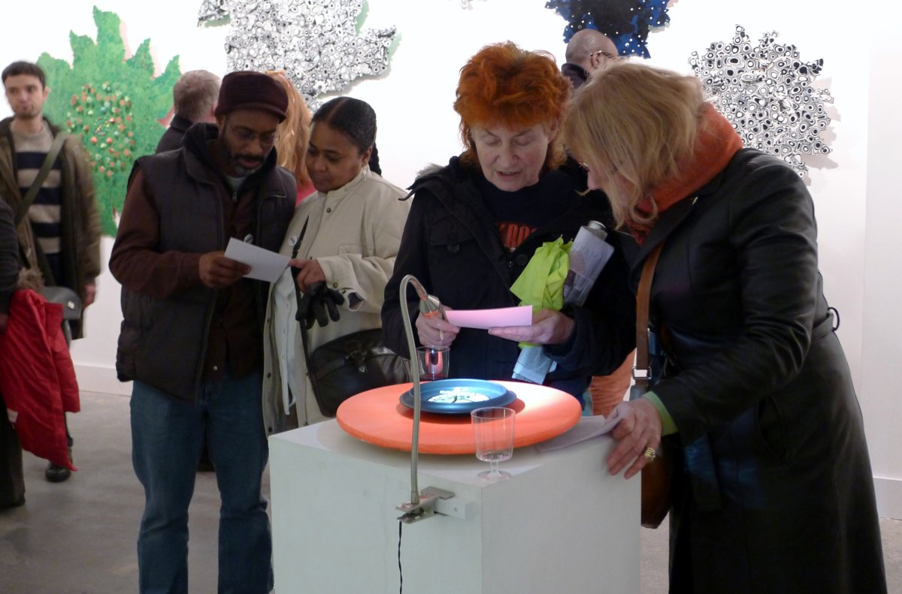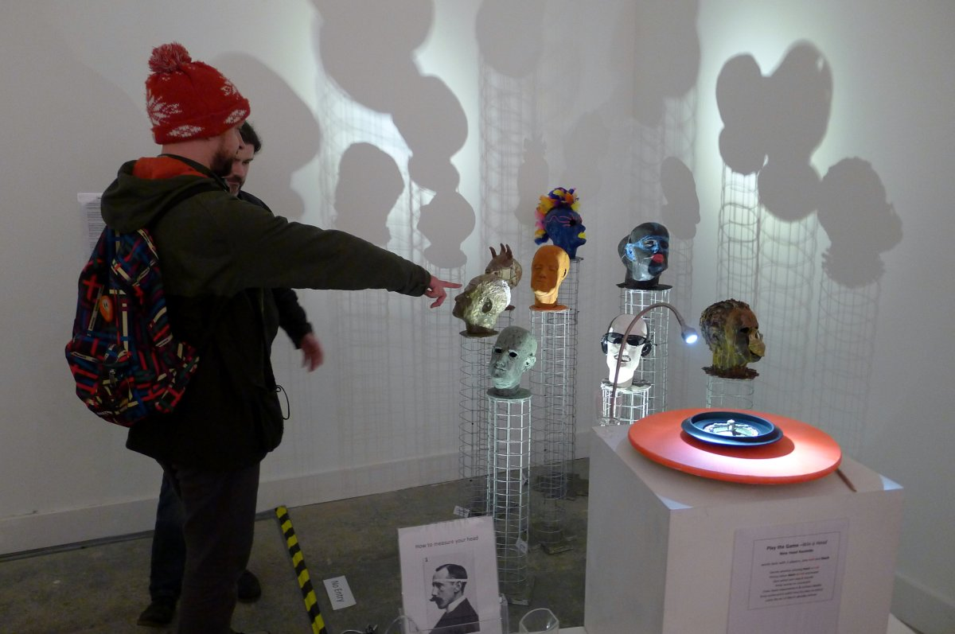

“It is seldom that we hear of a white traveller meeting with a black chief who he feels to be the better man”
Sir Francis Galton (1822-1911) anthropologist, eugenicist, tropical explorer, geographer, inventor, meteorologist, proto-geneticist, psychometrician, and statistician
“In the most intelligent races, as among the Parisians, there are a large number of women whose brains are closer in size to those of gorillas than to the most developed male brains. This inferiority is so obvious that no one can contest it for a moment; only its degree is worth discussion”
Gustave Le Bon (1841-1931) social psychologist, sociologist, and amateur physicist
“(we choose)...for our comparison of brains, races whose intellectual inequalities are completely clear. Thus the superiority of Europeans compared with Africa Negroes, American Indians, Hottentots, Australians and the Negroes of Oceania, is sufficiently certain to serve as a point of departure for the comparison of brains”
“In general the brain is larger in mature adults than the elderly, in men than in women, in eminent men than in men of mediocre talent, in superior races than inferior races”
Paul Broca (1824-1880) physician, surgeon, anatomist, and anthropologist
“The human body can be measured in a thousand ways. Any investigation, convinced beforehand of a group’s inferiority, can select a small set of measures to illustrate its greater affinity with apes or children, or the feeble minded or an earlier stages of civilisation....
“(Broca) shifted criteria to work through good data towards desired conclusions. Heads I’m superior; tails, you’re inferior”
Stephen J Gould (1941-2002) paleontologist, evolutionary biologist, and historian of science

Nine Head Roulette
In this installation each head alludes to one of the indices that were used in C19th Europe and America to place human beings on an evolutionary scale based on the shape of the head or features of the brain. A focus on surface differences led to a blindness towards the deeper unity - that all human beings are taken from the same mould. The value placed on human beings became a game of chance. Each person’s place on the evolutionary ladder depended on the race, gender, constitution and class into which they were born. With the distance of time it’s tempting to dismiss this kind of thinking as special pleading by a particular dominant group to justify its position as lords of creation, meriting special privileges. But these people were also some of the best scientists of their age, priding themselves on their objectivity. And such ideas, particularly in relation to mental abilities, are still around.

Play the Game –Win a Head
Nine Head Roulette
works best with 2 players, one red one black
Decide whether playing black or red
Pickup either black or red scorecard
Spin wheel and play 8 rounds
Enter scores on scorecard
Enter head measurement & contact details
Drop scorecard in ballot box (no play no entry)
Lucky dip on 12 March decides winner

